Content (drag and drop photo directly onto doc or add box link)  **If post includes multiple photos, please add a link to the box folder where the photo resides | Title | Created by | Text for post:  include no more than two hashtags  Tag appropriate accounts for correct platform | Comments | Platform:  Facebook, Twitter, Instagram | Approved by (Initial) | Deadline | Published  Y/N
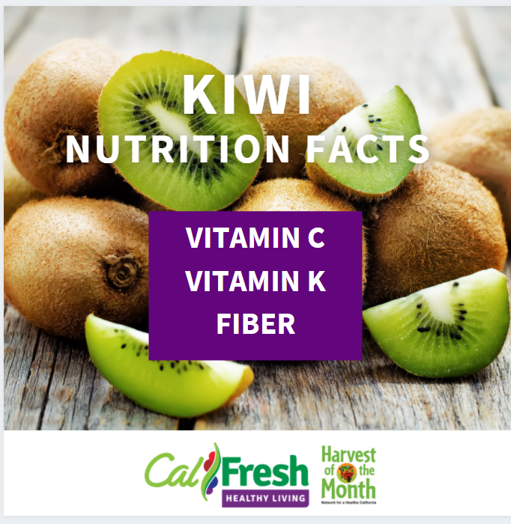 | HOTM: Kiwi Week 1: Nutrition Facts | Sheena | Did you know…  Kiwis are one of the most nutrient-dense fruits.  Vitamin C – is only found in plants.  Vitamin K – is important for wound healing  You can eat the skin for extra fiber. |  |  |  | 2/1
 | HOTM: Kiwi Week 2: How to pick fruit/veg at the market | Sheena | The size of a kiwi doesn’t affect the taste. Kiwis will keep for several days at room temperature and up to four weeks in the refrigerator. |  |  |  | 2/8
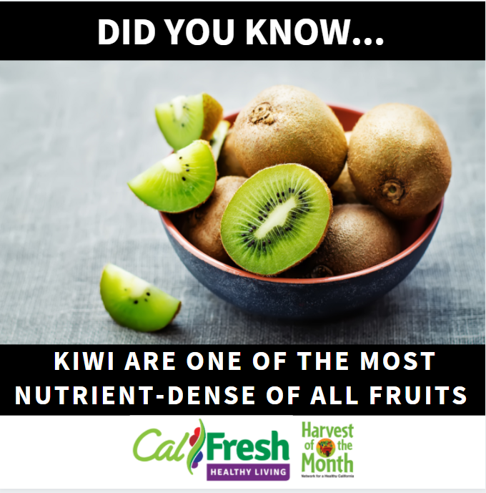 | HOTM: Kiwi Week 3: Other varieties | Sheena | Kiwi Fun Facts:  Kiwis contain an enzyme that acts as a natural meat tenderizer.  Kiwis are actually a berry.  Kiwis grown on vines that can be as high as 30 feet. |  |  |  | 2/15
 | HOTM: Kiwi Week 4: Recipe | Sheena | Add kiwi to your next fruit salad. Try this easy recipe from eatfresh.org.  Honey Gingered Fruit Salad |  |  |  | 2/22
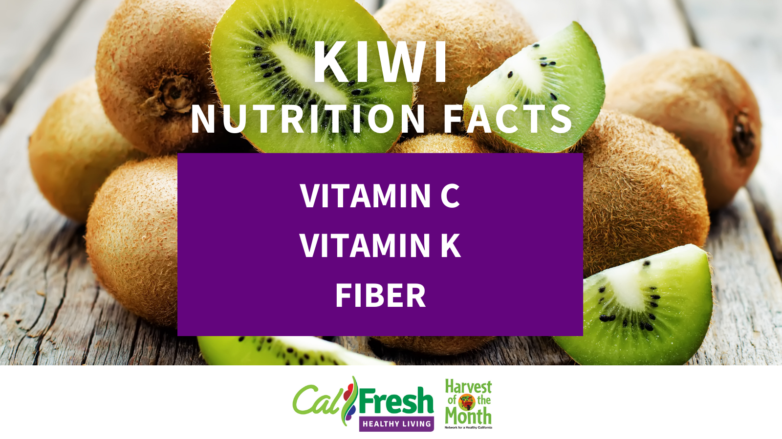  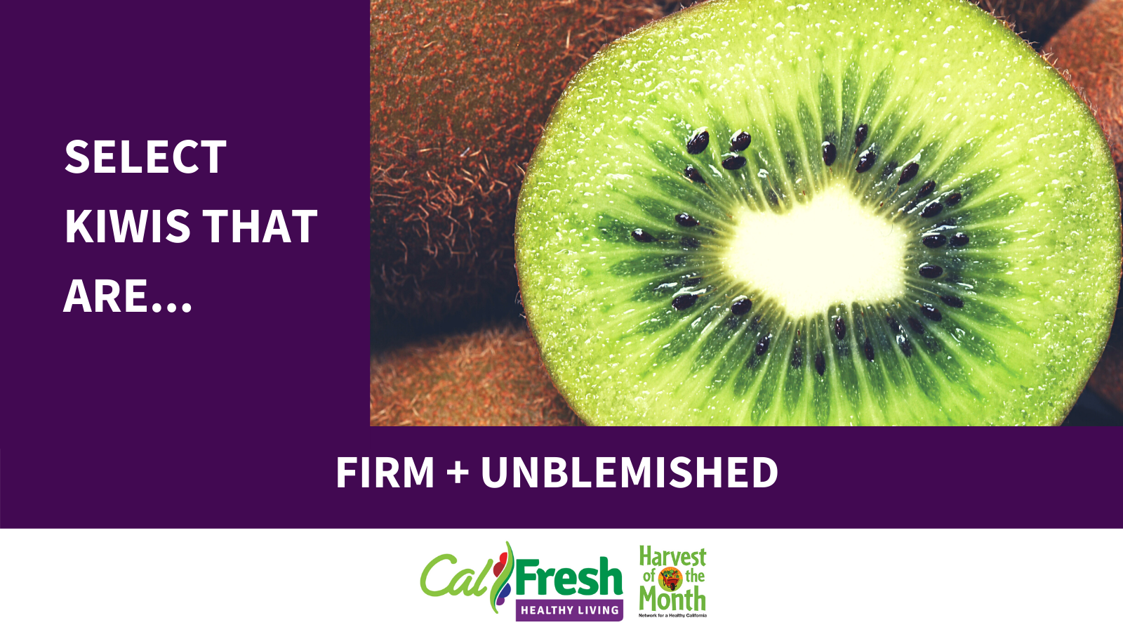  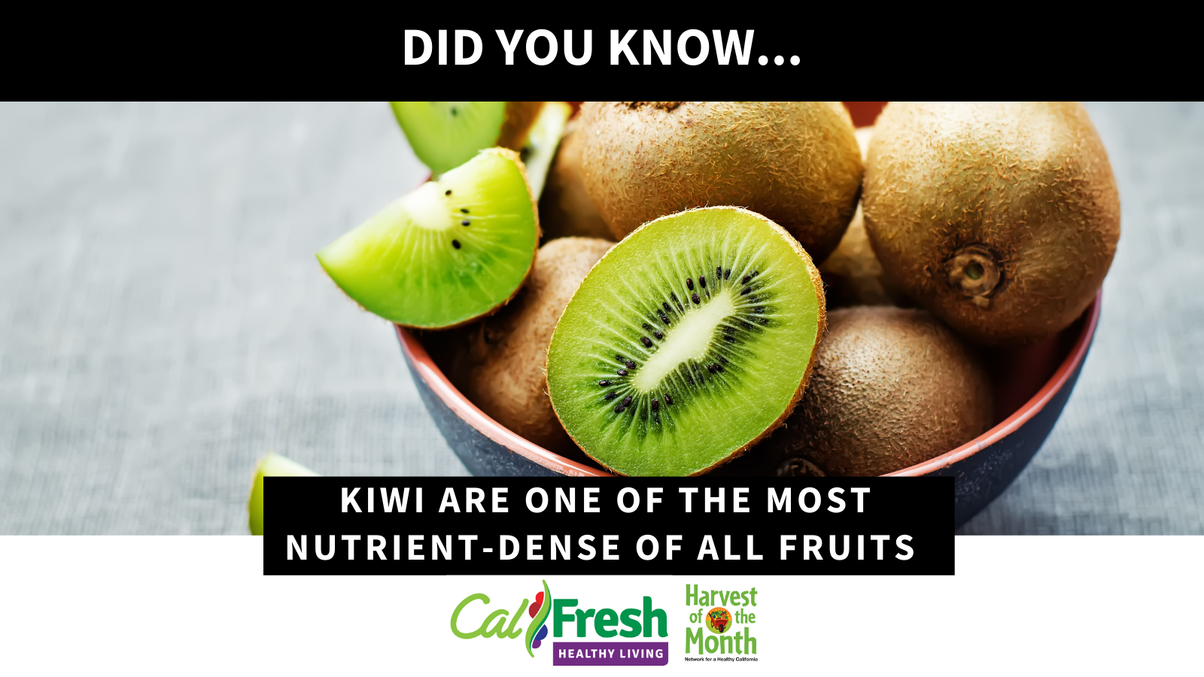 |  |  | Twitter posts
 |  |  | Twitter posts

 | Suggestions | Examples Text
Hashtags: #, lets users apply dynamic, user-generated tagging that helps other users easily find messages with a specific theme or content. Hashtags are used in text. | #CalFreshHealthyLiving  #SNAP-Ed  #HOTM (double check might be #HarvestOfTheMonth)  #DayofAction (#RTYD #HealthySnackDay)
Accounts: @, Partners and shoutouts. CSU Campuses | Facebook:  Instagram:  Twitter:  Pinterest:

Target Audience:
For the work on our own campus, we will want to promote classes, HOTM, recipes, campus PSE efforts, partner highlights, and student testimonials.
As the prime contractor, we also want to take the lead with social media posts so partners campuses can share, retweet, etc. We could highlight partner successes, post generic CFHL posts, share relevant news, increase awareness and share outcomes.

Goal for Project:
Share successes with funders or partners; Increase awareness about program; Increase number of participants in program; Promote events (online and offline); Meet required Scope of Work item(s); Interact with partners via social media;
Posting monthly (1-3post/mo) **subject to changed due to activity of the program.
-HOTM: mandatory 1 post/mo
-Day of action: mandatory (what time line would you like? Consistent posting or when events are happening on the campus, 1 post/week and real time posting closer and during the event?)
-Recipe Highlights: 1 post/month
-Partner Highlights/Student testimonies: 1 post/month
-PSE Efforts: Posting TBD by project timeline

Comments:
Social media Toolkit
https://csuchico.box.com/s/jdpnaf438nobystbbsyb3diaegbbgv5b

SOW? Yes- Harvest of the Month promotions and Days of Action

