How to access the analytics tab:
- Log into your getcalfresh.org CBO account though the assister sign- in option, located at the bottom left of the webpage
- In the upper left of the webpage, you will see three tabs labeled, “clients”, “analytics”, and “assisters”
- Click on the “analytics tab”.
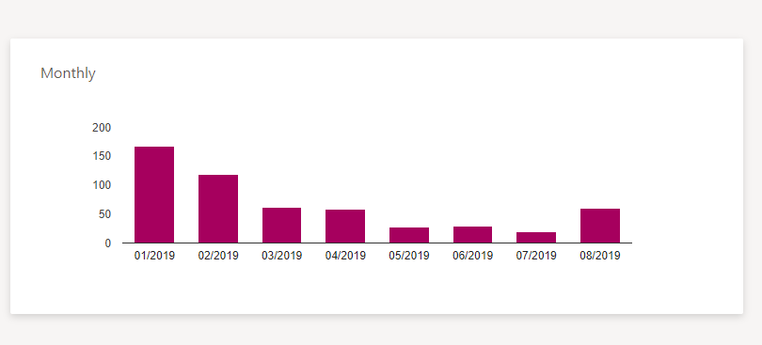
- You will then see a table in the middle of the webpage that looks like this:

- Next, using your computer mouse, drag your mouse over the first month in the reporting quarter. For example, if you are reporting for Quarter 4, the first month would be July.
- With your mouse hovered over July, you should see a number pop-up, this number is the number of applications submitted for that month.

- With the number of applications still showing, you are ready for your first screenshot.
- Repeat for the other two months.
For information on how to take a portal screenshot, please see below.
How to take a screenshot on a PC:
- Depending on the version of PC you have, there are two methods of taking a screenshot.
- One way to take a screenshot, is to hold down Ctrl and PrtScn (usually located in the upper right hand of your key board)
- You should see your computer screen flicker or darken, this will indicate the screenshot was taken. You can find the screenshot in your computers pictures folder. A new folder will be created called “screenshots”.
- If this does not work, you may need to use the Windows key. This looks like the Windows logo and is located near the Ctrl button.
- You will need to the hold down the Windows button, PrtScn, and Ctrl simultaneously.
- You should see your computer screen flicker or darken, the screenshot should show up in your computers pictures folder. You screenshot should look like this:
Please be aware that if you are using two screens, the screenshot will be taken of both screens. If this happens, you can crop out the second screen using the “snipping tool” on your PC before you send the screenshot.

