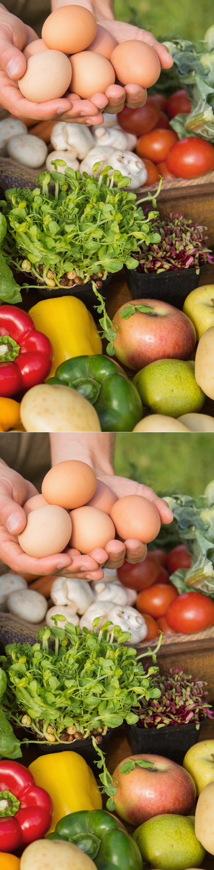
CalFresh EBT at Farmers’ Markets

In Partnership with the [Add Market Name]
[Add what the market offers such as CalFresh EBT Accepted, Market Match]
FREE: [Add What Your Team Offers below]
Market Walks Cooking Demo/Tasting
Support farmers and our local economy
Contact us at [Add phone] or [Add Email]

Add Farmers’ Market Logo and Campus Logo Here. Add CalFresh Logo and tagline if using for CalFresh Outreach.

CalFresh EBT at Farmers’ Markets

In Partnership with the [Add Market Name]
[Add what the market offers such as CalFresh EBT Accepted, Market Match]
FREE: [Add What Your Team Offers below]
Market Walks Cooking Demo/Tasting
Support farmers and our local economy
Contact us at [Add phone] or [Add Email]
Add Farmers’ Market Logo and Campus Logo Here. Add CalFresh Logo and tagline if using for CalFresh Outreach.

