Prescreen Tracking
All subcontractors are required to report prescreen numbers quarterly in the Prescreen Tracking tab.
- Indicate the quarter the prescreen(s) took place by using the drop-down options in the quarter column (column A).
- List the date or date range (column B) that the prescreen(s) took place
- Describe where the prescreens took place in the outreach description/setting column (column C).
For example, if you conducted a virtual outreach event that utilized an online prescreen form, you would enter the date of the event and the total number of prescreens from the form.
An example would look like this:
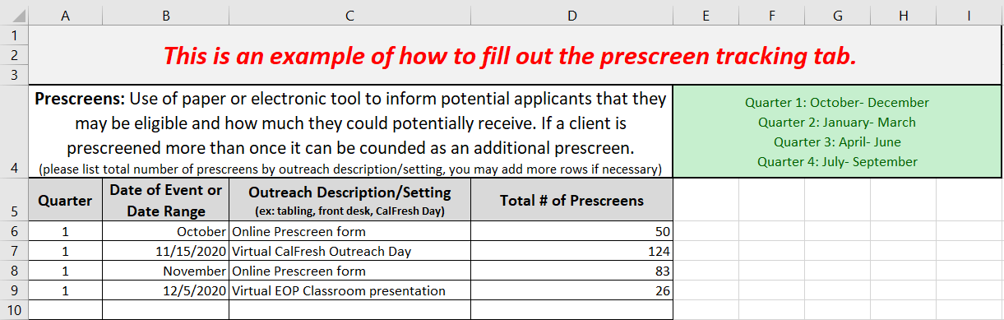
Partnership Tracking
All subcontractors are required to report partnership numbers quarterly in the Partner Tracking tab.
- Indicate the quarter the partnership took place by using the drop down options in the quarter column (column A).
- List the date of the partnership (column B) and indicate if it was a training or collaborative meeting using the drop down options (column C).
- List the partner name (column D) and briefly describe the partnership in 1-2 sentences (column E).
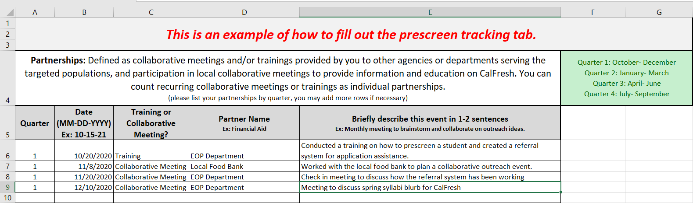
An example would look like this:

Quarter Tabs (Q1, Q2, Q3, Q4)
Tracking applications submitted in the Quarter Tab may or may not be required depending upon the way the application is submitted as noted below:
For applications submitted through GetCalFresh.org (via the assistor CBO account or the referral URL) YOU ARE NOT REQUIRED to input those applications in the Quarter Tab.
- Instead, we get monthly reports from Code for America that show the total number of applications submitted via your assistor account and referral URL. Because of this, you do not need to duplicate efforts by entering those applications into the Quarter Tab.
- Note: However, if you would LIKE to use the Quarter Tab in the master log for your internal tracking and/or follow up processes, you may.

For applications submitted through any other method (C4Yourself, CalWIN, YBN, Paper, County Worker, etc.) you ARE REQUIRED to enter in those applications in the Quarter Tab.
- These applications are not included in the Code for America report so we must collect this data.
- Fill out all columns in the master log the same way you have done in the past.
- Note: The student exemptions section is now optional and you can collect this information if you choose too.

Additionally, all subcontractors are required to report verifications (SAR7 and Recertifications) submitted on behalf of a client in the Quarter Tab as noted below:
- Use the drop-down option in the type of assist column (column C) and mark “verification”.
  - After marking verification, you’ll see specific boxes automatically shade in. Please do not fill out these cells.
- In the type of verification column (column D), indicate if it was an “original application, SAR7, or RE”.
An example would look like this:
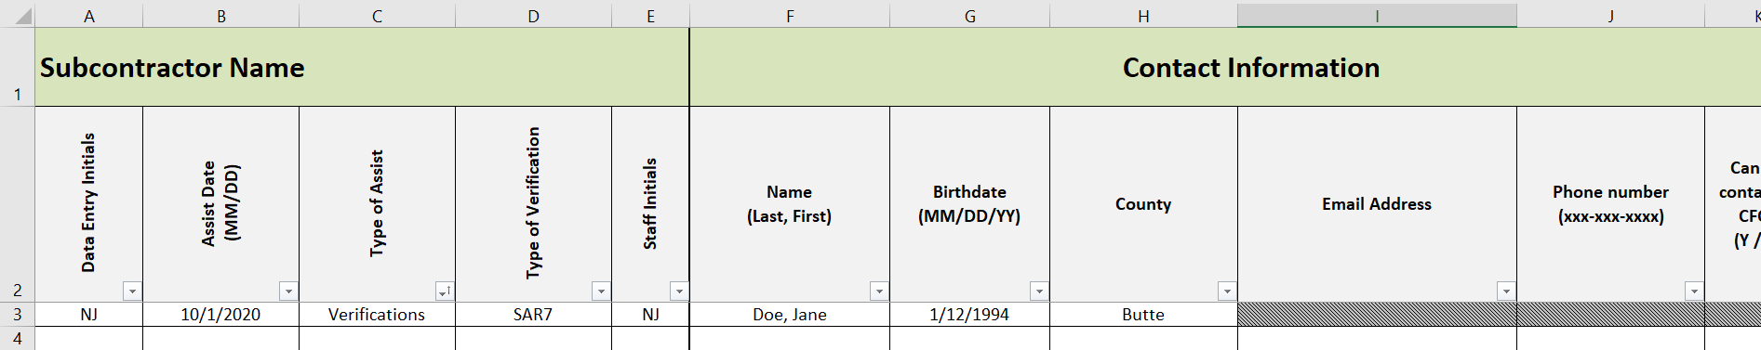

Follow-ups
Our funders, California Department of Social Services (CDSS) has requested that we use an approval rate that is generated from monthly CalFresh Custom State reports. For Year 3, we will apply that approval rate to your electronic applications submitted. This means that you are no longer required to submit follow-up information.
Subcontractors are still required to conduct follow ups for applications submitted to ensure your clients have all the support they need. You can choose to do your follow-ups in the following ways:
- In the GetCalFresh case notes
- In an external log
- In the master log

