Content (drag and drop photo directly onto doc or add box link)  **If post includes multiple photos, please add a link to the box folder where the photo resides | Title | Created by | Text for post:  include no more than two hashtags  Tag appropriate accounts for correct platform | Comments | Platform:  Facebook, Twitter, Instagram | Approved by (Initial) | Deadline | Published  Y/N
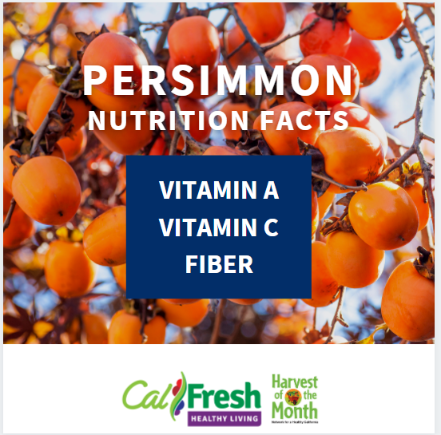 | HOTM: Persimmon Week 1: Nutrition Facts | Sheena | This month we are featuring Persimmons as our #Harvestofthemonth  Vitamin A – keeps our eyes healthy, our immune system strong, and our cells growing  Vitamin C – keeps our immune system strong  Fiber – keeps your gut healthy and feeling full | Title hard to read. Black background, transparency |  |  |  | FB:  11/2  12:25pm  Insta: 11/2 8:55am
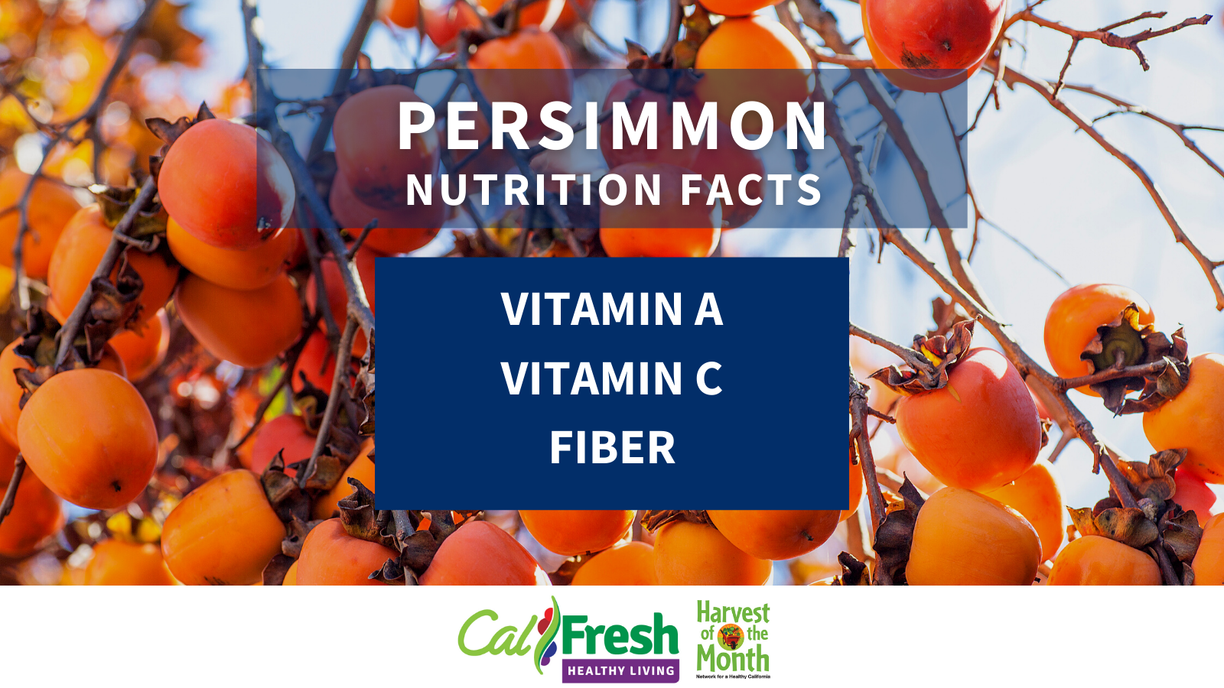 |  |  | This month we are featuring Persimmons as our #Harvestofthemonth  Vitamin A – keeps our eyes healthy, our immune system strong, and our cells growing  Vitamin C – keeps our immune system strong  Fiber – keeps your gut healthy and feeling full |  | Twitter |  |  | 11/2 9:05am
 | HOTM: Persimmon Week 2: How to pick fruit/veg at the market | Sheena | Ripe Fuyus are firm when ready to eat and can be kept at room temperature for up to three weeks. Hachiyas are ripe when soft and slightly wrinkled. To speed up ripening of Hachiyas, place in a paper bag with an apple or banana. | Remove green box |  |  |  | FB: 11/9  12:25pm  Insta: 11/9  10:55 am
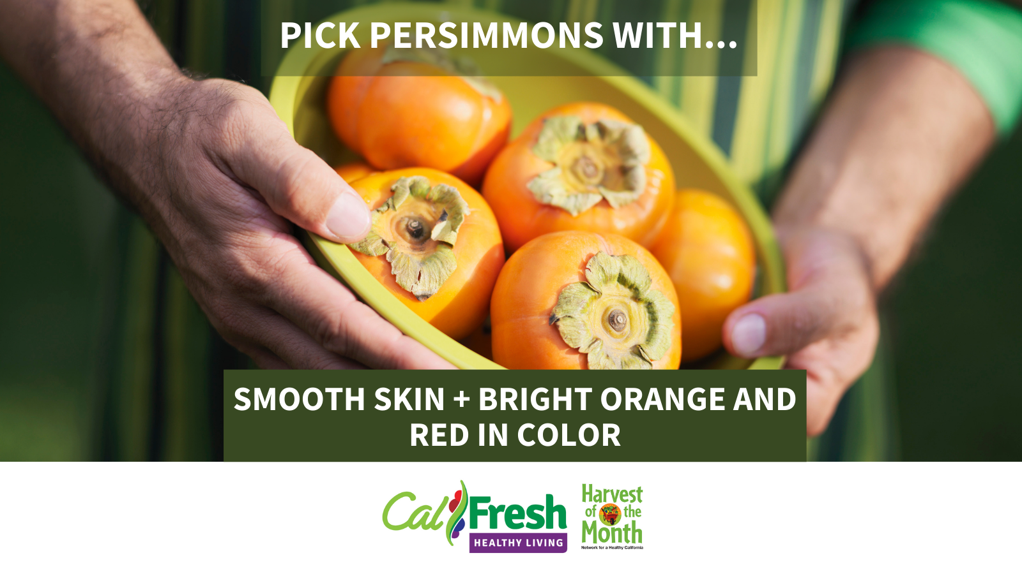 |  |  | Ripe Fuyus are firm when ready to eat and can be kept at room temperature for up to three weeks. Hachiyas are ripe when soft and slightly wrinkled. To speed up ripening of Hachiyas, place in a paper bag with an apple or banana. |  | Twitter |  |  | 11/9 10:15am
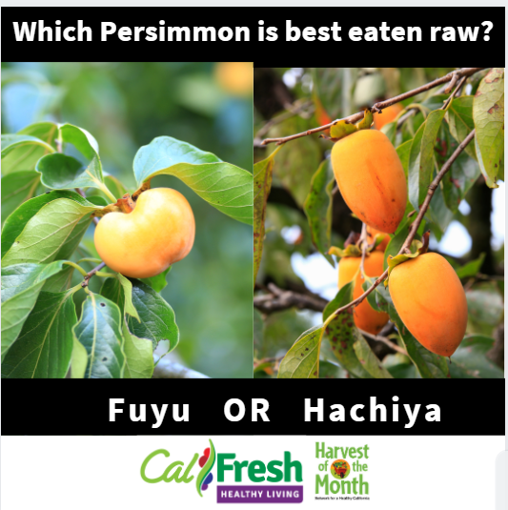 | HOTM: Persimmon Week 3: Other varieties | Sheena | Fuyu persimmons are best eaten raw. Hachiyas are mostly used in baking and can be eaten by scooping the flesh out with a spoon. |  |  |  |  | FB:  11/16  12:25pm  Insta:  11/16 8:25am
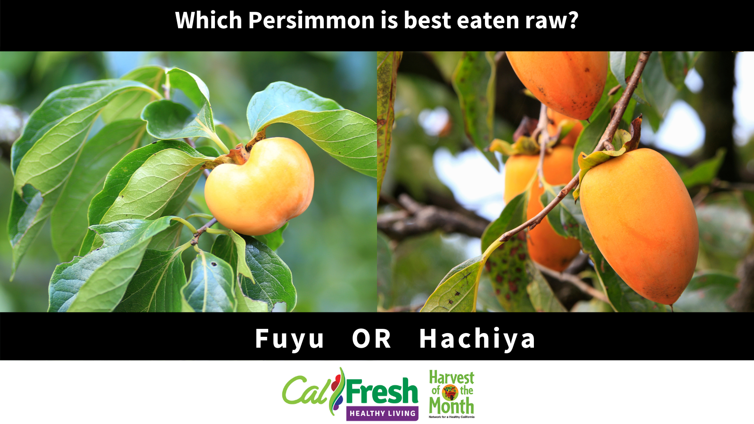 |  |  | Fuyu persimmons are best eaten raw. Hachiyas are mostly used in baking and can be eaten by scooping the flesh out with a spoon. |  | Twitter |  |  | 11/16 10:50am
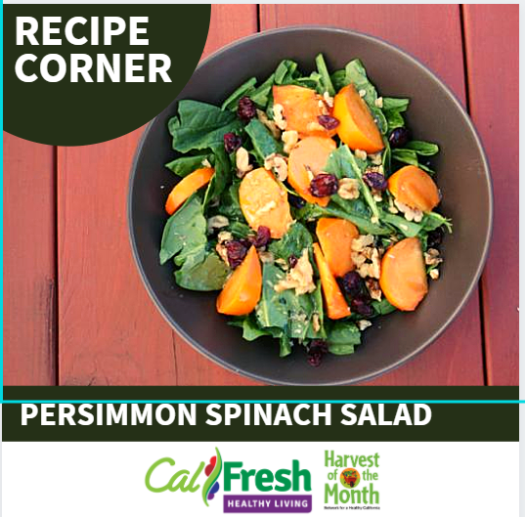 | HOTM: Persimmon Week 4: Recipe | Sheena | Try this easy recipe, it requires no cooking and can be made using basic equipment: cutting board, knife, and bowls to mix dressing and salad together.  https://eatfresh.org/recipe/side-dish-salads/persimmon-spinach-salad#.X49goNBKi70  Instagram: Try this easy recipe, it requires no cooking and can be made using basic equipment: cutting board, knife, and bowls to mix dressing and salad together. Find the recipe by visiting EatFresh.org | Remove green box |  |  |  | FB: 11/23 12:25 pm  Insta: 11/23  8:25 am
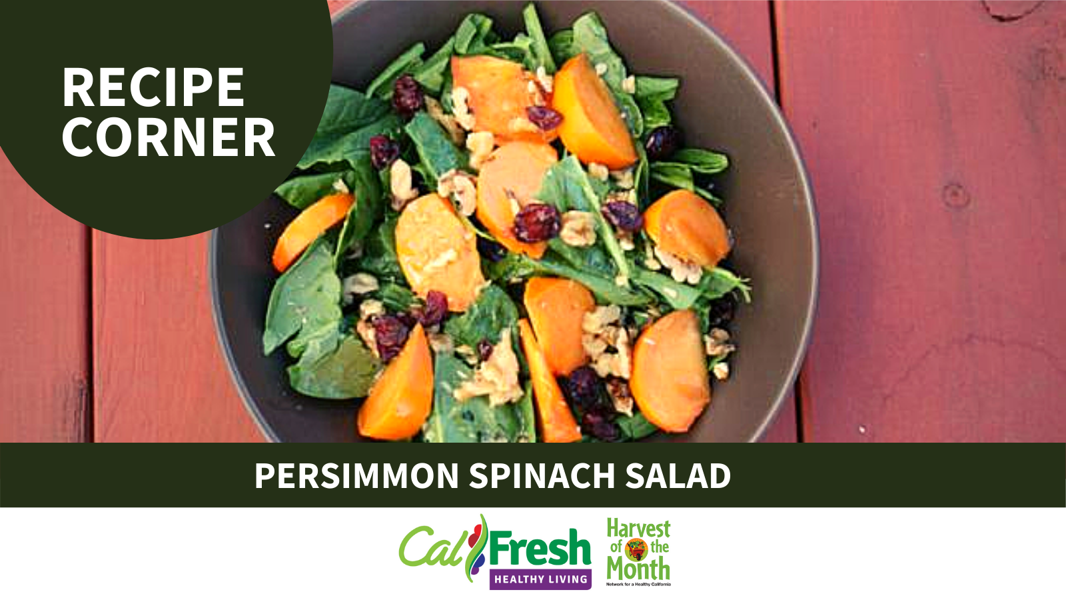 |  |  | Try this easy recipe, it requires no cooking and can be made using basic equipment: cutting board, knife, and bowls to mix dressing and salad together.  https://eatfresh.org/recipe/side-dish-salads/persimmon-spinach-salad#.X49goNBKi70 |  | Twitter |  |  | 11/23 10:15 am

 | Suggestions | Examples Text
Hashtags: #, lets users apply dynamic, user-generated tagging that helps other users easily find messages with a specific theme or content. Hashtags are used in text. | #CalFreshHealthyLiving  #SNAP-Ed  #HOTM (double check might be #HarvestOfTheMonth)  #DayofAction (#RTYD #HealthySnackDay)
Accounts: @, Partners and shoutouts. CSU Campuses | Facebook:  Instagram:  Twitter:  Pinterest:

Target Audience:
For the work on our own campus, we will want to promote classes, HOTM, recipes, campus PSE efforts, partner highlights, and student testimonials.
As the prime contractor, we also want to take the lead with social media posts so partners campuses can share, retweet, etc. We could highlight partner successes, post generic CFHL posts, share relevant news, increase awareness and share outcomes.

Goal for Project:
Share successes with funders or partners; Increase awareness about program; Increase number of participants in program; Promote events (online and offline); Meet required Scope of Work item(s); Interact with partners via social media;
Posting monthly (1-3post/mo) **subject to changed due to activity of the program.
-HOTM: mandatory 1 post/mo
-Day of action: mandatory (what time line would you like? Consistent posting or when events are happening on the campus, 1 post/week and real time posting closer and during the event?)
-Recipe Highlights: 1 post/month
-Partner Highlights/Student testimonies: 1 post/month
-PSE Efforts: Posting TBD by project timeline

Comments:
Social media Toolkit
https://csuchico.box.com/s/jdpnaf438nobystbbsyb3diaegbbgv5b

SOW? Yes- Harvest of the Month promotions and Days of Action

