Daily Pantry Audit Checklist:
Your campus: ___________________
Most campus pantries are not considered a Limited Service Charitable Food Operation (LSCFO) because they do not and will not do the following. It is recommended that you talk to your campus risk management department and environmental health and safety department.
Please verify that your pantry is not:
Holding hot food to distribute later (ex: holding hot soup) | □ Yes | □ No
Reheating previously hot food to distribute later (ex: microwaving previously hot food) | □ Yes | □ No
Cooling hot food (ex: putting hot food in the refrigerator) | □ Yes | □ No
Portioning commercially prepared foods (ex: portioning bagged cut fruit) | □ Yes | □ No
Cooling any food that has been or may have been in the temperature danger zone (41-135 degrees F) | □ Yes | □ No
Thaw frozen foods to distribute later (ex: thawing frozen meat) | □ Yes | □ No
The only exception is if the food comes directly from refrigerator or freezer and has been confirmed by the retail operation and documented by pantry staff.
If you checked ‘yes’ to any of the above, it is recommended you contact your risk management department and environmental health and safety department as you may have to comply with a different set of guidelines.
Refrigerator and Freezer Temperature:
It is recommended that the temperatures be taken twice a day, once when the pantry opens and once when it closes. Please use the table below to record your temperatures. Please note the time that each temperature was taken as well as the temperature.
Recommended Temperatures:
Refrigerator: at or below 40 degrees F
Freezer: at 0 degrees F
If the refrigerator or freezer are not at the correct temperature, please fill in the corrective action.
Examples of a corrective action: calling your campus maintenance department, discarding all foods that could have been in the temperature danger zone, discarding melted food items, etc.
Refrigerator Temperature #1 | Time taken: | Temperature: | Staff initials: | Date: | Corrective Action:
Refrigerator Temperature #2 | Time taken: | Temperature: | Staff initials: | Date: | Corrective Action:
Freezer Temperature #1 | Time taken: | Temperature: | Staff initials: | Date: | Corrective Action:
Freezer Temperature #2 | Time taken: | Temperature: | Staff initials: | Date: | Corrective Action:

Handwashing Station:
Is the handwashing station set up when the pantry opens? | □ | Staff initials: | Date:
Are the single use paper towels, soap, and potable water being changed as needed? | □ | Staff initials: | Date:
Is the handwashing station being cleaned and sanitized as needed throughout the day? | □ | Staff initials: | Date:
Is the wastewater emptied when the pantry closes? | □ | Staff initials: | Date:
Cleaning and Sanitizing/Chemical Storage:
Are all chemicals or cleaning supplies labeled and stored in an area away from food? | □ | Staff initials: | Date:
Are surfaces that contact ready-to-eat food (i.e. dry storage shelves, refrigerator shelves, produce bins freezer) being cleaned and sanitized? It is recommended this be done once a week or daily. | □ | Staff initials: | Date:
Are the floors cleaned/swept daily for pest management? | □ | Staff initials: | Date:
Are trashes and boxes taken out at the end of each shift? | □ | Staff initials: | Date:
Food Inspection:
Are all damaged or expired foods being discarded daily? | □ | Staff initials: | Date:
Are all dry storage foods being rotated daily to follow the ‘first in, first out’ (FIFO) rule? This ensures that the oldest food is in the front and taken first. | □ | Staff initials: | Date:
Are you logging all donations that are accepted in the inventory/receiving log? | □ | Staff initials: | Date:
If produce is from a home garden, are you asking the recommended question about domestic animals? | □ | Staff initials: | Date:

Receiving Log:

Please fill out the log when donations are received.
If the produce is from a home garden please ask: Are there domestic animals like dogs, cats, and chickens roaming the garden?
All home garden produce must have a posted sign stating that garden produce should be taken at own risk.

Date/Time | Name of Donor/Origin of Food | Food Items (ex: cans, dry goods, produce, eggs) | Is the produce from a home garden or farm? | How will food be stored? | When should food be discarded?
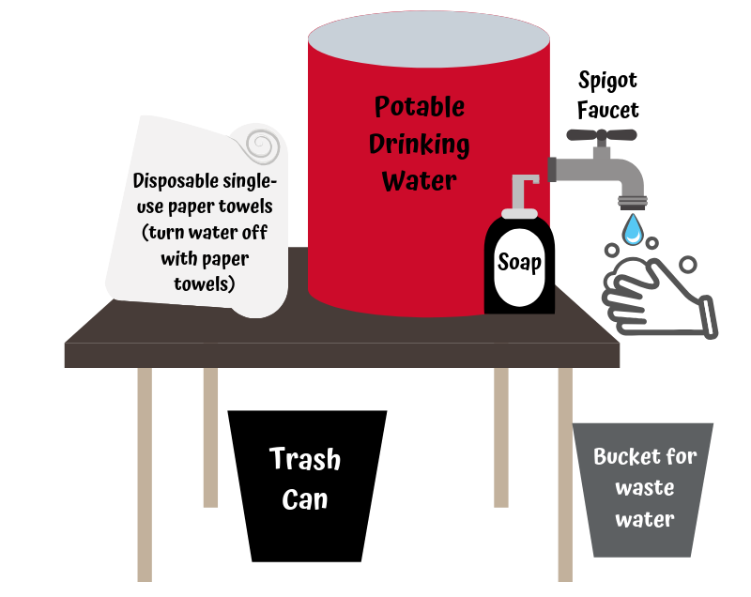
Handwashing Station Set-up/Checklist:
Materials List
A clean container for water, with a spigot (no push buttons) | □
Liquid soap in a pump dispenser (hand sanitizer does not replace handwashing) | □
Disposable single-use paper towels | □
Trash can | □
A bucket or catch basin to collect the dirty water | □

