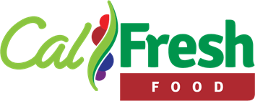
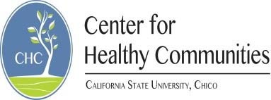
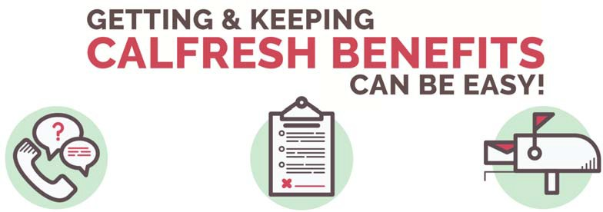

Application
- Your county eligibility worker will call or mail you interview date and time within 2 weeks—answer phone and check mail

Interview
- Usually via phone
- From blocked/private number
- Takes about 30 minutes
- Can be rescheduled

Veriﬁcations
  - Gather requested documents and mail, fax or drop oﬀ at your county’s oﬃce
  - Conﬁrm with caseworker that veriﬁcations were received

Application Date: Your local county oﬃce’s # is:
*Important Note: Once you have your intake interview you will be given 10 days to submit your veriﬁcations. If they are not received within 10 days, then you will automatically receive a denial notice. However, YOU ARE NOT ACTUALLY DENIED until you have reached 30 days from the date of your application. If you miss the initial 10-day deadline it is OK, just get your veriﬁcations to the county as soon as possible.

Don’t Forget:
    - You have the right to ask for help to get the proof that is needed, to have 10 days for submitting requested proof, and to ask for a state hearing within 90 days.
    - You have the responsibility to report changes as required and to cooperate with County, State and Federal personnel.
    - You are committing a crime if you give false or wrong information, or do not give all the information on purpose to try to get CalFresh beneﬁts that you are not eligible to receive, or to help someone else get beneﬁts that they are not eligible to receive. You must pay back any beneﬁts you were not eligible to receive.
    - You will need to report if your income goes above your IRT (Income Reporting Threshold) within 10 days—your IRT will be sent to you in the mail after you are approved for beneﬁts.
    - You should update your address with your case worker/unit as if it changes– this ensures that you receive important documents and communication.

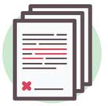
After You’ve Received Your Beneﬁts
SAR 7 (6 months)
Report any changes in income or household

Please Contact Us For Help!
RE (1 year)
Recertify—complete interview and veriﬁcations

CalFresh Outreach can help you through the entire CalFresh application process.
We can make free copies, fax veriﬁcations, answer questions and help along the way!
Call us at [Phone number] or email us at [Email]

Visit us at [Location] [Days and times] or by appointment

Funded by USDA SNAP, known in California as CalFresh, an equal opportunity provider and employer, and the California Department of Social Services. Revised on 7/23/18

