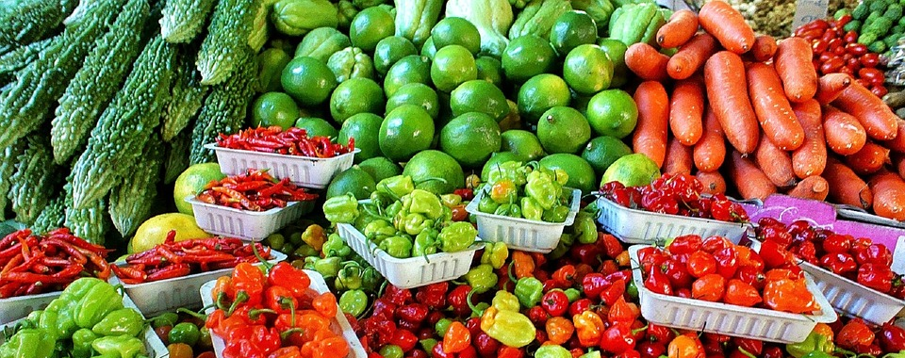

Use CalFresh benefits at the farmers’ Market!

[Add market name] from [Add time]
Location: [Add address]
Benefits available at this market: [Add benefits here, such as Market Match, EBT accepted, Cal Fresh assistance, etc.]

[Add market name] from [Add time]
Location: [Add address]
Benefits available at this market: [Add benefits here, such as Market Match, EBT accepted, Cal Fresh assistance, etc.]

[Add market name] from [Add time]
Location: [Add address]
Benefits available at this market: [Add benefits here, such as Market Match, EBT accepted, Cal Fresh assistance, etc.]

Don’t have CalFresh? We can help you apply!
[Add phone number] or email [Add email address]
Address: [Add address for assistance location]
(Add logos for your market here)

Funded by USDA SNAP, known in California as CalFresh, an equal opportunity provider and employer, and the California Department of Social Services.

