Application Date: _______  Staff Initials: ___________ | Method of Assistance: □ Appointment □ Walk-In □ Call-In □ Outreach □ Outreach w/ County  How Did You Hear About CalFresh?: □ Word of Mouth □ Online □ Presentation □ Flyer □ Other
Name: _______________________________________________________ DOB: _________________ County: _______________
Address: ________________________________________ Apt. ________ City: ____________________ Zip: _________________
Email: _____________________________________________________ Phone: ________________________________________
Can we text, call, or email you regarding your CalFresh application, and can we identify as CalFresh Outreach? □ Yes □ No
□ Paper Application □ Online Application Confirmation Number: _____________________________________________________
Check ALL BOXES that apply to the applicant’s household:
□ College Student per CalFresh regulations  □ Children Under 18  □ Military/Veteran | □ Working Low-Income  □ Receiving SSI  □ None of These Apply | □ Older Adult (60+)  □ Language Access Barrier  □ Displaced

Half-time or more students only – Which of the following exemptions do they meet? Check ALL that apply:
□ Working and getting paid for at least 20 hours per week, or 80 hours per month on average
□ Approved, awarded, or accepted work study, anticipates working, and has not refused a job
□ Attending CSU, UC, or private college, and receiving Cal Grant A or B – unmarried, under 25, and annual income under $50,000
□ Enrolled in EOP(S), WIOA, DSPS, CARE, UC McNair, or MESA
□ Enrolled in Guardian Scholar, FYSI, CAFYES, Chafee ETV, or Extended Foster Care
□ Exerting parental control of a dependent under 6 OR has parental control of a dependent under 12 with no adequate childcare
□ Participating in in CFET or JOBS, or CalWORKS
□ Enrolled in other approved program(s) on the State list: http://bit.ly/CFApproved
Comments:
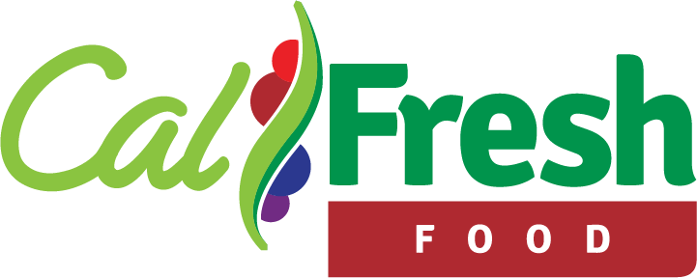Funded by USDA SNAP, known in California as CalFresh, an equal opportunity provider and employer, and the California Department of Social Services.

Application Date: _______  Staff Initials: ___________ | Method of Assistance: □ Appointment □ Walk-In □ Call-In □ Outreach □ Outreach w/ County  How Did You Hear About CalFresh?: □ Word of Mouth □ Online □ Presentation □ Flyer □ Other
Name: _______________________________________________________ DOB: _________________ County: _______________
Address: ________________________________________ Apt. ________ City: ____________________ Zip: _________________
Email: _____________________________________________________ Phone: ________________________________________
Can we text, call, or email you regarding your CalFresh application, and can we identify as CalFresh Outreach? □ Yes □ No
□ Paper Application □ Online Application Confirmation Number: _____________________________________________________
Check ALL BOXES that apply to the applicant’s household:
□ College Student per CalFresh regulations  □ Children Under 18  □ Military/Veteran | □ Working Low-Income  □ Receiving SSI  □ None of These Apply | □ Older Adult (60+)  □ Language Access Barrier  □ Unknown

Half-time or more students only – Which of the following exemptions do they meet? Check ALL that apply:
□ Working and getting paid for at least 20 hours per week, or 80 hours per month on average
□ Approved, awarded, or accepted work study, anticipates working, and has not refused a job
□ Attending CSU, UC, or private college, and receiving Cal Grant A or B – unmarried, under 25, and annual income under $50,000
□ Enrolled in EOP(S), WIOA, DSPS, CARE, UC McNair, or MESA
□ Enrolled in Guardian Scholar, FYSI, CAFYES, Chafee ETV, or Extended Foster Care
□ Exerting parental control of a dependent under 6 OR has parental control of a dependent under 12 with no adequate childcare
□ Participating in in CFET or JOBS, or CalWORKS
□ Enrolled in other approved program(s) on the State list: http://bit.ly/CFApproved
Comments:
Funded by USDA SNAP, known in California as CalFresh, an equal opportunity provider and employer, and the California Department of Social Services.

